Menopause in the workplace

  - Guidance for managers, supervisors and colleagues supporting anybody going through the menopause

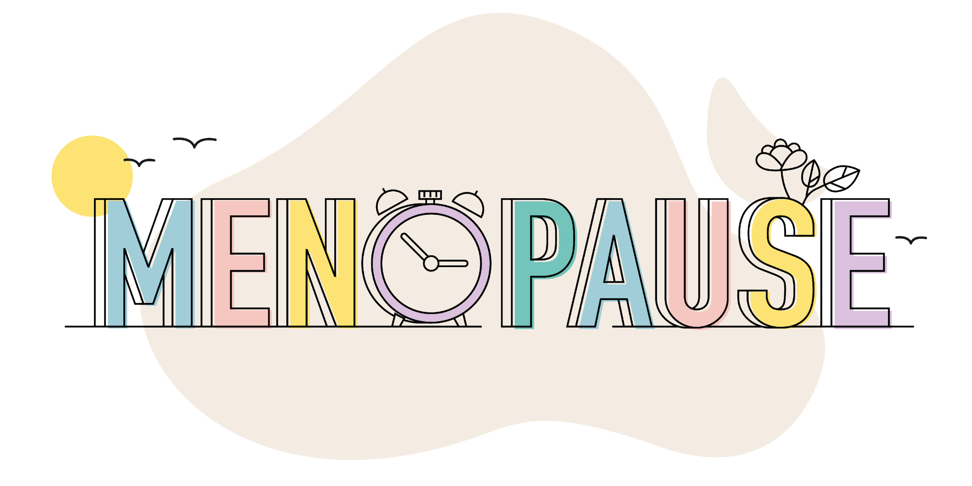
Contents
Purpose of this guidance 1
Who is this guidance for? 1
Context and definitions 1
Why is this important? 2
Symptoms 2
Impact of symptoms 2
Discussing the menopause 2
Support and Adjustments 3
Internal support 3
External support 4

Purpose of this guidance
Menopause is a natural part of life, and should not be taboo or hidden. This guidance aims to increase awareness and provide managers, supervisors and colleagues with the tools they need to support anyone going through, or approaching, the menopause. It aims to create an environment where people feel able to talk openly about the menopause without embarrassment. Menopause can be a difficult time, and the right support can improve experiences both in and outside of work.

Who is this guidance for?
This guidance is aimed at anybody in the University community who manages, or supports in any way, a person going through the menopause. Most people going through the menopause in the University will be staff. However, some students are affected, and this guidance is also aimed at supervisors or personal tutors who are supporting them.

It is important to remember that not everybody who experiences the menopause identifies as a woman. Support needs to be available for everybody at this time of change, regardless of their gender identity.

Context and definitions
Menopause is defined as one year after the date of the last menstrual period. It usually occurs between the ages of 45 and 55, but it can come earlier or later.

The perimenopause is the time leading up to the menopause when symptoms are experienced. The perimenopause can last for several years before the menopause itself occurs.

The postmenopause is the time following the menopause. Symptoms can continue into the postmenopause, sometimes for several years.

Menopause which begins before the age of 40 is known as POI (Premature Ovarian Insufficiency), or premature menopause. This can happen spontaneously or for medical reasons, such as hysterectomy or treatment for some cancers.

Why is this important?
Research led by the University of Bristol on menopause in the workplace has shown that negative experiences are common. Fewer than half of the respondents had disclosed their menopause status at work, with many feeling that their abilities would be questioned. 30% said that their experience of discussion of menopause at work was that it was joked about.

Poor experiences mean that many women have, or have considered, leaving the workplace during their menopause. Providing the right support can help to ensure that nobody in the University suffers negative experiences, and can continue to thrive in the workplace. It will also help the University to retain the skills and knowledge of experienced staff.

Symptoms
Everyone is different, and experiences vary. However, most people going through the menopause experience some symptoms, and in some cases these can be severe. The most common symptoms can include:

- Hot flushes
- Irregular periods which can be unmanageable at times
- Night sweats and difficulty sleeping
- Problems concentrating
- Issues with cognition – often known as ‘brain fog’
- Mood changes and low mood
- Joint stiffness
Symptoms can be made worse if they are experienced alongside other medical conditions.
Further details about symptoms can be found on the menopause pages of the NHS website.

Impact of symptoms
Symptoms can have a negative impact on people’s experiences in the University. Some of these impacts could include:

- Tiredness
- Poor concentration and memory
- Stress
- Loss of confidence
Other factors can also increase the impact of symptoms. For instance, if people have caring responsibilities for children or elderly relatives, this could worsen effects such as tiredness. Research shows that experiences of the menopause are more positive if people are supported. It is important that people do not feel that they are alone, or that they are to blame for any negative effects of their symptoms.

Discussing the menopause
Menopause is often a taboo and people do not always feel comfortable in disclosing it to their managers and colleagues, especially if they are not sure that they will be taken seriously. If a staff member or student does wish to speak about their experiences, you should:

- Allow enough time
- Find an appropriate, informal space where there will be no interruptions
- Bear in mind that they might be embarrassed and try to make them feel as comfortable as possible
- Listen carefully and allow them to speak openly and honestly. Remember that everybody’s experiences are different and don’t make generalisations.
- Make sure they know they are being taken seriously and that any requests for adjustments will be treated sympathetically
- Maintain confidentiality at all times
- Make them aware of the Meno-pause Café (staff only), and signpost to other sources of support and information, both within and outside the University (see below)
- Arrange follow up meetings if requested
There are resources available which will help you to prepare for the meeting if you feel you would like more information beforehand. You can find further details at the end of this guidance.

You might be approached by someone who is not going through the menopause but is affected by it in some other way, for example if a partner or family member is going through the menopause. If this happens, do not allow any conversations to breach confidentiality. It is never appropriate to discuss a colleague or a student’s menopause status with another member of staff unless they have given full consent and are part of the discussion.

Support and Adjustments
Research shows that those who take active steps to manage their symptoms are likely to have a better experience of the menopause. The right support and adjustments can help them to do this.

- If the person is struggling with their symptoms, or if you are aware that they are under 40, advise them to visit their GP if they haven’t already
- Consider making adjustments to working hours to work around symptoms, including flexibility around taking breaks and working from home where possible
- Make sure the working environment is as comfortable as possible taking into account temperature control and providing desk fans. Make washing and changing facilities available, and ensure that people know where they can find them
- Be flexible with time off for medical appointments
- Provide any equipment or assistive technology which could help
In most cases, you will be able to make adjustments without the need to refer to the Occupational Health service. However, a referral can be helpful if you would like advice or guidance. If the person asks to be referred to Occupational Health, the Occupational Health Referrals – Guidance for Managers provides details on the process.

Keep a record of any adjustments which are agreed and give a copy to the person so they can share it, as appropriate, in the future if they wish. If there is a change in manager, do not share this or any other information with the new manager without the person’s consent, as this would breach confidentiality. If their role and circumstances remain the same, the new manager will be advised to accept the adjustments already agreed.

Internal support within the University
Policies, procedures and guidance:
- Human Resources
- Flexible working policy
- Dignity and mutual respect policy
- Managing stress at work
Services:
- Meno-Pause for Thought café (staff only)
- Wellbeing, Safety and Health Services
- Occupational Health Service
- Staff Counselling and Psychological Support
- Student Counselling, Wellbeing and Mental Health Support

Workshops:
- OD&PL Menopause in the Workplace for Managers

External support
Information, guidance and resources from external organisations:

- NHS Menopause Guidance website
- National Institute for Health and Care Excellence (NICE) guidelines - explains how GPs will determine what types of treatments and interventions can be offered.
- The Royal College of Obstetricians and Gynaecologists – offer a dedicated hub to enhance knowledge of the menopause and improve support.
- Faculty of Occupational Medicine - provides information about menopause within the workplace.
- Women’s Health Concern – provides information about all aspects of women’s health, including the menopause.
- International Menopause Society – information and resources from world leading experts, translated into multiple languages. The IMS lead World Menopause Day, on 18 October each year.
- Business In The Community Menopause in the Workplace Toolkit and Webinar – advice for HR, Wellbeing, and Occupational Health practitioners.
- Business In The Community Mid-life MOT – helps employers to support staff with a range of wellbeing needs in mid-life.

Websites providing support on managing the menopause, and insights into personal experiences:

- Henpicked
- Over the Bloody Moon
- The Daisy Network – for people going through POI (Premature Ovarian Insufficiency)

