Menopause in the workplace

  - Guidance for individuals who are going through, or approaching the menopause

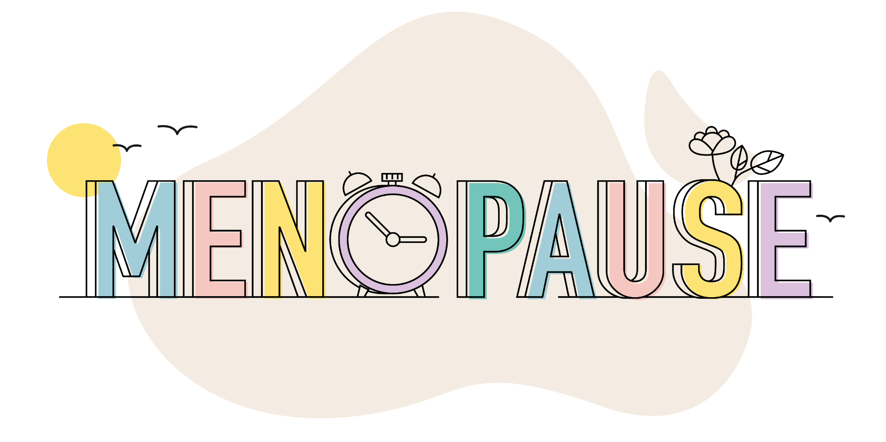
Contents
Purpose of this guidance 1
Who is this guidance for? 1
Context and definitions 1
Symptoms 2
Impact of symptoms 2
Discussing the menopause 2
Support and adjustments 2
Internal support within the University 3
External support 4

Purpose of this guidance
Menopause is a natural part of life, and should not be taboo or hidden. This guidance aims to increase awareness of the support which is available for anyone going through this transition.

Menopause can be a difficult time, and the right support can improve experiences both in and outside of work.

Who is this guidance for?
This guidance is for anybody in the University community who is going through, or is approaching the menopause. The University recognises that some people experiencing the menopause do not identify as women, and aims to support everybody, regardless of their gender identity.

Most people going through the menopause in the University will be staff. However, this guidance is also aimed at any students who are affected.

Context and definitions
Menopause is defined as one year after the date of the last menstrual period. It usually occurs between the ages of 45 and 55, but it can come earlier or later.

The perimenopause is the time leading up to the menopause when symptoms are experienced. The perimenopause can last for several years before the menopause itself occurs.

The postmenopause is the time following the menopause. Symptoms can continue into the postmenopause, sometimes for several years.

Menopause which begins before the age of 40 is known as POI (Premature Ovarian Insufficiency), or premature menopause. This can happen spontaneously or for medical reasons, such as hysterectomy or treatment for some cancers.

The menopause is one example of a number of hormonal changes that people may experience in their lifetimes.

Symptoms
Everyone is different, and experiences vary. However, most people going through the menopause experience some symptoms, and in some cases these can be severe. The most common symptoms can include:

- Hot flushes
- Irregular periods which can be unmanageable at times
- Night sweats and difficulty sleeping
- Problems concentrating
- Issues with cognition – often known as ‘brain fog’
- Mood changes and low mood
- Joint stiffness
Symptoms can be made worse if they are experienced alongside other medical conditions.
Further details about symptoms can be found on the menopause pages of the NHS website.

If you are under 40, or if your symptoms are affecting your day-to-day life, you should visit your GP who will be able to give support including treatment and guidance on lifestyle changes which may help. Research show that people who take active steps to manage their symptoms are likely to have a better experience of the menopause.

Impact of symptoms
Symptoms can have a negative impact on quality of life and your experience in the University. These impacts could include (but are not limited to):

- Tiredness
- Poor concentration and memory
- Stress
- Loss of confidence
If you feel that your symptoms are affecting your work or study, there is action that the University can take to support you.

Discussing the menopause
Telling the University about your menopause status is a personal choice. However if you have practical needs to help you manage your symptoms at work/study, you should speak to an appropriate manager (or your personal tutor/supervisor if you are a student), if you feel comfortable doing so. If you do not feel comfortable, consider whether there are any other managers or staff members you would prefer to approach. You can also contact HR. Confidential support is also available from Staff Counselling and Psychological Support or Student Counselling, Wellbeing and Mental Health Support.

Support and adjustments
If you feel that practical support and adjustments would help, you can ask your manager, or HR, to make a referral to Occupational Health, who will be able to assess and recommend appropriate adjustments.

Adjustments could include:
- Adjustments to working hours to work around symptoms, including flexibility around taking breaks and working from home where possible
- Facilitating a more comfortable working environment, taking into account temperature control and providing desk fans
- Flexibility around attending medical appointments
- Provision of washing and changing facilities for people to change clothes during the day
- Providing any equipment or assistive technology which could help
In most cases, an appropriate manager will be able to make adjustments without making a referral to the Occupational Health Service. However, Occupational Health can be helpful in giving advice and guidance on workplace adjustments.

The appropriate manager will keep a record of any agreed adjustments. You will also receive a copy so you can share it in the future if you wish. If there is a change in your manager, the information will not be shared with your new manager without your consent. If your role and circumstances remain the same, the new manager will be advised to accept the adjustments already agreed (with your consent).

If you are a student, you can contact Student Support and Wellbeing to discuss adjustments which can be made to help you with your studies.

Internal support within the University
Peer support:
- Research shows that emotional and peer support can help to improve experiences. The University runs a monthly Meno-Pause for Thought Café meeting, which provides a safe, respectful and confidential space to discuss the menopause and is open to all staff
- The Women at Leeds Staff Network provides peer support for staff

Workshops:
- Menopause in the Workplace sessions are run monthly either face-to-face or on Teams and can be booked via OD&PL.

Policies, procedure and guidance:
- Human Resources
- Flexible working policy
- Dignity and mutual respect policy
- Managing stress at work

Services:
- Wellbeing, Safety and Health Services
- Occupational Health Service
- Staff Counselling and Psychological Support
- Student Counselling, Wellbeing and Mental Health Support

External support
Information, guidance and resources from external organisations:

- NHS Menopause Guidance website
- National Institute for Health and Care Excellence (NICE) guidelines - explains how your GP will determine what types of treatments and interventions they can offer you.
- The Royal College of Obstetricians and Gynaecologists – offer a dedicated hub to enhance knowledge of the menopause and improve support.
- Faculty of Occupational Medicine - provides information about menopause within the workplace.
- Women’s Health Concern – provides information about all aspects of women’s health, including the menopause.
- International Menopause Society – information and resources from world leading experts, translated into multiple languages. The IMS lead World Menopause Day, on 18 October each year.

Websites providing support on managing the menopause, and insights into personal experiences:

- Henpicked
- Over the Bloody Moon
- The Daisy Network – for people going through POI (Premature Ovarian Insufficiency)

